Data Structures and Algorithms by [**Elshad Karimov**](https://tcsglobal.udemy.com/user/elshad-karimov/)

Time Complexity

To prepare for Data Structures and Algorithms (DSA) interviews for FAANG companies (Facebook, Amazon, Apple, Netflix, Google), you'll need a solid understanding of key concepts and problem-solving techniques. Here's a structured list of topics that will help you prepare:

**1. Mathematics and Number Theory**

* **Time Complexity Analysis (Big O, Omega, Theta)**: Understanding algorithmic complexity is crucial.
* **Recursion**: Recursive problem solving and recursion trees.
* **Mathematical Induction**
* **Prime Numbers**: Sieve of Eratosthenes, prime factorization.
* **Greatest Common Divisor (GCD), Least Common Multiple (LCM)**: Euclidean algorithm.
* **Modular Arithmetic**: Used in many algorithmic problems, especially related to large numbers.
* **Combinatorics**: Permutations, combinations, and basic probability.

**2. Arrays and Strings**

* **Array Manipulation**: Searching, sorting, sliding window, two-pointer technique.
* **Subarrays**: Maximum subarray (Kadane’s algorithm), prefix sums.
* **String Matching Algorithms**: KMP algorithm, Rabin-Karp.
* **Anagram Problems**: String sorting, hashing for anagram detection.
* **Pattern Matching**: Regular expressions, substring search.
* **Substring problems**: Longest common substring, longest palindromic substring, etc.

**3. Linked Lists**

* **Singly and Doubly Linked Lists**: Insertion, deletion, and traversal.
* **Reverse a Linked List**: Iterative and recursive solutions.
* **Detecting Cycles**: Floyd’s Tortoise and Hare algorithm.
* **Intersection of Linked Lists**: Using hashmaps, two-pointer technique.
* **Flattening Linked Lists**: Flattening multi-level linked lists.

**4. Stacks and Queues**

* **Basic Operations**: Push, pop, peek, and size.
* **Stacks**: Use of stacks for balanced parentheses, reversing expressions.
* **Queues**: FIFO implementation, circular queues.
* **Priority Queue**: Min-heap, max-heap, and heap operations.
* **Implementations using Stacks**: Queue using stacks, or vice versa.
* **Deque**: Double-ended queue operations.
* **Sliding Window**: Using queues/stacks for sliding window problems.

**5. Hashing**

* **Hash Tables**: Hash map, hash set, handling collisions (chaining, open addressing).
* **Hash Functions**: Designing good hash functions.
* **Applications**: Anagram detection, counting frequencies, finding duplicates, etc.
* **LRU Cache**: Using hash maps and doubly linked lists.

**6. Trees**

* **Binary Trees**: Traversal techniques (preorder, inorder, postorder).
* **Binary Search Trees (BST)**: Insertion, deletion, search.
* **Balanced Trees**: AVL Trees, Red-Black Trees.
* **Heaps**: Min-heap, max-heap, heapify operations.
* **Trie**: Prefix trees for storing strings, autocomplete, and spell check.
* **Segment Trees & Fenwick Trees (Binary Indexed Trees)**: Range queries, range updates.
* **Lowest Common Ancestor (LCA)**: Binary Lifting, Tarjan’s algorithm.

**7. Graphs**

* **Graph Representation**: Adjacency list, adjacency matrix, edge list.
* **Graph Traversal**: Depth-First Search (DFS), Breadth-First Search (BFS).
* **Topological Sorting**: For Directed Acyclic Graphs (DAGs).
* **Shortest Path Algorithms**: Dijkstra's algorithm, Bellman-Ford algorithm, Floyd-Warshall algorithm.
* **Minimum Spanning Tree (MST)**: Kruskal’s algorithm, Prim’s algorithm.
* **Graph Connectivity**: Connected components, Union-Find / Disjoint Set Union (DSU).
* **Cycle Detection**: In directed and undirected graphs.
* **Bipartite Graphs**: BFS/DFS for checking bipartiteness.
* **Strongly Connected Components (SCC)**: Kosaraju's algorithm, Tarjan’s algorithm.

**8. Dynamic Programming**

* **Basic DP**: Fibonacci series, climbing stairs, coin change problem.
* **Optimal Substructure**: Solving problems by breaking them down into overlapping subproblems.
* **Memoization vs Tabulation**: Recursive vs iterative dynamic programming.
* **Knapsack Problem**: 0/1 knapsack, unbounded knapsack.
* **Longest Common Subsequence (LCS)**, **Longest Increasing Subsequence (LIS)**.
* **Matrix Chain Multiplication**.
* **DP on Trees**: Tree DP (e.g., maximum path sum in a binary tree).
* **DP for Subset Problems**: Subset sum, partition problem.

**9. Backtracking**

* **Backtracking Basics**: Solving problems like N-Queens, Sudoku, permutation generation, combination generation.
* **Subset and Combination Generation**: Using recursion to generate subsets/combinations.
* **Pruning**: Efficient backtracking by eliminating unpromising paths early.

**10. Greedy Algorithms**

* **Greedy Strategy**: Local optimal choice leading to a global optimum.
* **Activity Selection Problem**.
* **Fractional Knapsack**: Greedy approach to solving knapsack problem.
* **Huffman Coding**: Greedy for optimal prefix encoding.
* **Job Sequencing Problem**.
* **Interval Scheduling**.

**11. Divide and Conquer**

* **Basic Strategy**: Dividing the problem into subproblems, solving recursively, and combining results.
* **Merge Sort, Quick Sort**.
* **Closest Pair of Points**.
* **Matrix Multiplication**: Strassen's algorithm.
* **Binary Search**: Both iterative and recursive.
* **Majority Element**: Boyer-Moore Voting Algorithm.

**12. Bit Manipulation**

* **Basic Operations**: AND, OR, XOR, NOT, shifting (left, right).
* **Counting Set Bits**: Brian Kernighan’s algorithm.
* **Bit Masking**: Setting, clearing, and toggling bits.
* **Find Unique Element**: Using XOR for detecting unique elements in an array.
* **Power of Two**: Efficient checking using bitwise operations.

**13. String Algorithms**

* **Rabin-Karp Algorithm**: For substring search.
* **KMP (Knuth-Morris-Pratt)**: For efficient substring matching.
* **Z Algorithm**: Pattern matching in linear time.
* **Manacher’s Algorithm**: For finding the longest palindromic substring in linear time.

**14. Advanced Topics (Optional but Helpful)**

* **Suffix Arrays**: Efficient string matching.
* **Bloom Filters**: Space-efficient probabilistic data structure.
* **Data Structure Design**: Custom data structures, like a balanced BST, Trie, etc.
* **Heavy-Light Decomposition**: For path queries on trees.

**Resources for Preparation**

1. **Books**:
   * *Cracking the Coding Interview* by Gayle Laakmann McDowell.
   * *Elements of Programming Interviews* by Adnan Aziz.
   * *Introduction to Algorithms* by Cormen, Leiserson, Rivest, Stein (CLRS).
2. **Online Platforms**:
   * **LeetCode** (especially for FAANG-style questions).
   * **HackerRank**.
   * **CodeSignal**.
   * **Codeforces**.
   * **GeeksforGeeks**.
   * **InterviewBit**.
3. **Mock Interviews**:
   * Try platforms like *Pramp*, *interviewing.io* for mock interviews.
4. **YouTube Channels**:
   * *Tech Dummies*, *Abdul Bari*, *MyCodeSchool*, *Tushar Roy*.

**Tips for Preparation:**

1. **Practice consistently**: Aim for at least 2-3 problems a day.
2. **Master problem-solving techniques**: Learn patterns (like sliding window, two-pointer, dynamic programming on intervals, etc.) and apply them to different problems.
3. **Understand time complexity**: Always aim to optimize solutions and understand trade-offs between time and space complexity.
4. **Simulate interviews**: Solve problems in a timed environment to replicate interview conditions.
5. **Mock interviews**: Get feedback from others, especially in peer-to-peer interviews.

By thoroughly covering these topics, you’ll be well-equipped to tackle DSA interviews at FAANG companies.

How to learn DSA in Java? - <https://youtu.be/p-8YpVkG3aI>

25 Dec, 2024 – Today I will complete BigO Notation. I will complete it later.

BigO Notation

* + It is a metric we use to determine the efficiency of code.

25 Dec, 2024 – Today I will complete Arrays.

Array

* + An array is a DS that can store fixed size collection of similar elements with contiguous memory allocation.

2D Arrays are also stores as 1D i.e. linearly in memory as below:

Insert operation is O(1) time complexity.

Accessing an element is also O(1) time complexity.

Traversing an Array require O(N) time complexity.

Searching is also takes O(1) TC.

Deleting an element from array is, setting that index to Integer.MIN_VALUE; and it takes O(1) time complexity.

Creation of 2D Array

Insert operation is O(1) time complexity.

Accessing an element takes O(1) time complexity.

Traversing a 2D array has O(mn) time complexity.

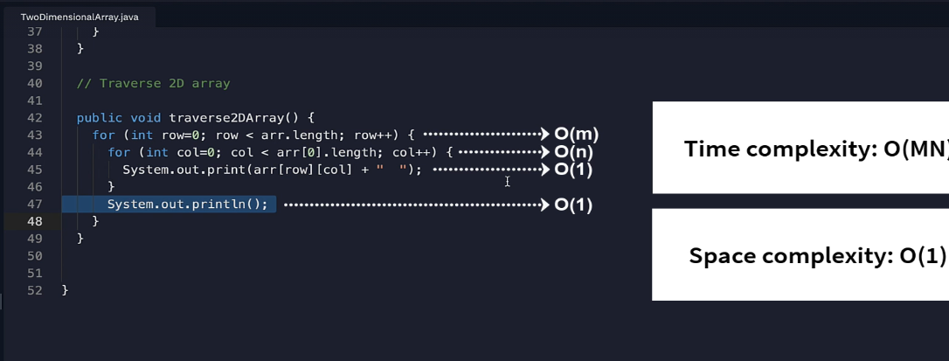

Searching in 2D array has O(mn) time complexity.

Deleting a value has O(1) time complexity.

